* Copyright for test papers and marking guides remains with *West Australian Test Papers*.
* The papers may only be reproduced within the purchasing school according to the advertised conditions of sale.
* Test papers must be withdrawn after use and stored securely in the school until Friday, Dec 1, 2017

**HUMAN BIOLOGY**

**Unit 1 and 2**

**2016**



Name: _______________________________________________________

Teacher: ___________________________________________________

**Time allowed for this paper**

Reading time before commencing work: ten minutes

Working time for the paper: three hours

**Materials required/recommended for this paper**

***To be provided by the supervisor:***

This Question/Answer Booklet

Multiple Choice Answer Sheet

***To be provided by the candidate:***

Standard items: pens (blue/black preferred), pencils (including coloured), sharpener, correction fluid/tape, eraser, ruler, highlighters

Special items: non-programmable calculators approved for use in this examination.

**Important note to candidates**

No other items may be taken into the examination room. It is **your** responsibility to ensure that you do not have any unauthorised material. If you have any unauthorised material with you, hand it to the supervisor **before** reading any further.

**Structure of this paper**

|  |  |  |  |  |  |
| --- | --- | --- | --- | --- | --- |
| Section | Number of questions available | Number of questions to be attempted | Suggested working time (minutes) | Marks available | Percentage of examination |
| Section One  Multiple-choice | 30 | All | 40 | 30 | 30 |
| Section Two:  Short answers | 8 | All | 90 | 103 | 50 |
| Section Three:  Extended answers | 3 | 2 | 50 | 40 | 20 |
|  |  |  |  | **Total** | 100 |

**Instructions to candidates**

1. The rules for the conduct of the Western Australian Certificate of Education ATAR course examinations are detailed in the *Year 12 Information Handbook 2017*. Sitting this examination implies that you agree to abide by these rules.

2. Answer the questions according to the following instructions.

Section One: Answer all questions on the separate Multiple-choice answer sheet provided. For each question, shade the box to indicate your answer. Use only a blue or black pen to shade the boxes. If you make a mistake, place a cross through that square, then shade your new answer. Do not erase or use correction fluid/tape. Marks will not be deducted for incorrect answers. No marks will be given if more than one answer is completed for any question.

Section Two: Write your answers in this Question/Answer booklet. Wherever possible, confine your answers to the line spaces provided.

Section Three: Consists of three questions. You must answer two questions. Identify the question you are answering.

3. You must be careful to confine your answers to the specific questions asked and to follow any instructions that are specific to a particular question.

4. Additional working space pages at the end of this Question/Answer booklet are for planning or continuing an answer. If you use these pages, indicate at the original answer, the page number it is planned/continued on and write the question number being planned/continued on the additional working space page.

**Section One: Multiple-choice 30% (30 Marks)**

This section has **30** questions. Answer **all** questions on the separate Multiple-choice Answer Sheet provided. For each question shade the box to indicate your answer. Use only a **blue or black pen** to shade the boxes. If you make a mistake, place a cross through that square, do not erase or use correction fluid, and shade your new answer. Marks will not be deducted for incorrect answers. No marks will be given if more than one answer is completed for any question.

Suggested working time: 40 minutes.

1. A microscope with a 10x ocular lens and 4x objective lens can fit seven mitochondria of 1mm in length. What will the field of view be with a 10x objective lens?
   1. 7000µm
   2. 17500µm
   3. **2800µm**
   4. 3500µm
2. In a controlled experiment, a scientist is studying the effect of increasing exercise bike resistance on heart rate and stroke volume. What is the independent variable?
   1. The time spent pedalling on the exercise bike
   2. **The resistance to pedalling**
   3. The type of exercise bike
   4. The heart rate and stroke volume
3. During the cellular respiration, approximately 38% of the energy available is used to synthesise ATP. The remaining 62% is
   1. stored as fat.
   2. **lost as heat.**
   3. within the products of cellular respiration.
   4. recycled.
4. Whilst running, the gluteus maximus and hamstrings work together to help perform a movement. What name is given to such a pair of muscles?
5. Antagonistic
6. Agonitic
7. Origins
8. **Synergitic**

**Use the following information to answer Question 5.**

A scientist placed human cells into a solution of potassium ions. At regular intervals the concentration of potassium ions in both the external solution and inside the cells were measured. The results are shown in the graph below.

External Solution

Internal Solution

1. By what process did the potassium ions leave the cell after 15 minutes?
   1. Exocytosis; as the potassium ions are too large to cross the cell membrane.
   2. Facilitated diffusion; as potassium moves against the concentration gradient.
   3. **Active transport; as potassium moves against the concentration gradient.**
   4. Endocytosis; as the potassium ions are too large to cross the cell membrane.
2. The plasma membrane is described as a ‘mosaic’. This means the membrane consists of
   1. a single layer of phospholipids with embedded proteins.
   2. **a phospholipid bilayer with embedded proteins.**
   3. a protein bilayer with embedded phospholipids.
   4. a single layer of proteins with embedded phospholipids.
3. A function of the circulatory system is to help maintain levels of particular substances. This can be achieved by
4. **transporting materials between the tissue fluid and the external environment.**
5. excreting wastes from the body.
6. digestion and metabolism of nutrients.
7. coordination of metabolic reactions.

**Use the diagram below of an erythrocyte in solution to answer Question 8.**

Water Molecule

Solute Molecule

1. What is the tonicity of the solution and the effect it will have on the cell?
2. **Hypotonic; cell will swell and lyse**
3. Hypotonic; cell will shrivel up
4. Hypertonic; cell will swell and lyse
5. Hypertonic; cell will shrivel up

**Use the information below to answer Question 9.**

A study investigating the effects of environment and genetics on the development of asthma was undertaken. The data below shows the correlation coefficient for both of the twins having asthma.

|  |  |
| --- | --- |
| **Type of Twins** | **Correlation Coefficient** |
| Identical  Male | 0.82 |
| Identical  Female | 0.79 |
| Non-identical  Male | 0.27 |
| Non-identical  Female | 0.29 |

1. Which of the following best explains what the data suggests about the causes of asthma?
   1. **Large genetic influence**
   2. Large gender influence
   3. Large environmental influence
   4. Small genetic influence
2. 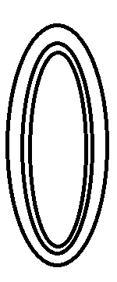The shapes below illustrate different blood vessels.

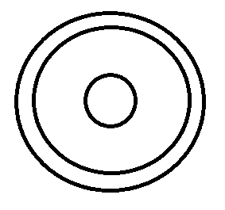

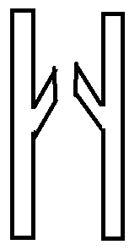

1 2 3 4

Which of the following correctly matches the shapes with the names of the blood vessels shown?

1. 1 = Capillary, 2 = Artery, 3 = Artery, 4 = Vein
2. 1 = Artery, 2 = Vein, 3 = Vein, 4 = Capillary
3. 1 = Vein, 2 = Artery, 3 = Capillary, 4 = Capillary
4. **1 = Artery, 2 = Vein, 3 = Capillary, 4 = Vein**
5. Police in Australia are armed with a taser. This device fires electrical impulses similar to that of action potentials into a suspect with a frequency of 15 to 20 per second.

Which of the following best explains the effect a taser has on a suspect’s muscles?

1. Causes the body to release neurotransmitters causing the muscles to contract and relax rapidly
2. Electricity is sent directly into the muscles causing them to contract uncontrollably
3. **Electric pulses match those used by neurons, which override the body’s natural signals and cause the muscles to rapidly twitch**
4. Hijacks the central nervous system, causing the muscles to contract and relax rapidly
5. Osteoporosis often shows no signs or symptoms. Which of the following would be an indicator to undergo testing for this disease?
   1. Pain in your legs and arms
   2. Feeling weak and tired
   3. Stiff joints with minimal movement
   4. **Loss of 3cm or more in height**
6. The majority of carbon dioxide is transported in the blood by
   1. Carbaminohaemoglobin
   2. **Bicarbonate ions**
   3. Oxyhaemoglobin
   4. Deoxyhaemoglobin
7. Reabsorption of ions, such as chlorine, in the nephron does **not** occur in the
   1. proximal convoluted tubule.
   2. **renal corpuscle.**
   3. distal convolute tubule.
   4. collecting duct.
8. The cartilage in the nose that provides form and support is best described as being
   1. **hyaline cartilage.**
   2. fibrocartilage.
   3. elastic cartilage.
   4. smooth cartilage.

**Use the diagram of the ballerina below to answer Question 16.**



1. The movement of the hip joint allowing the ballerina to lift her leg is best described as
   1. flexion.
   2. **abduction.**
   3. adduction.
   4. extension.
2. Cancer cells, although not under normal cell replication control, are not attacked by the body’s immune system. The best reason to explain why the body treats cancer cells as one of its own is that cancer cells contain the same
3. receptor proteins on the cell membrane as non-cancer cells.
4. receptor proteins embedded within the cell membranes as non-cancer cells.
5. **identity markers embedded within the cell membranes as non-cancer cells.**
6. identity markers found on the cell membrane as non-cancer cells.
7. A forensic officer collected biological evidence from a crime scene that was lacking nucleated cells. What biological technique may the investigator undertake to help detectives find the perpetrator?
8. DNA analysis
9. Marker analysis
10. PCR analysis
11. **mtDNA analysis**
12. The ABO blood system is an example of which type of genetic inheritance?
13. **Multiple Allele Inheritance**
14. Sex-linked Inheritance
15. Simple Inheritance
16. Polygenic Inheritance

**Use the information below to answer Question 20.**

Between 1944 and 1954 over 17,000 cases of Polio were notified in Australia, with 1000 deaths. One of the symptoms of polio is the inability to breathe easily due to the effects on the muscles of the respiratory system. This resulted in patients having to lie down in a machine called an iron lung for an extended period.

1. Which of the following is the **best** explanation of why patients in an iron lung are at risk of blood clots?
   1. Low levels of the mineral iron cause the thickening of blood which leads to clot formation
   2. **Prolonged lack of activity causing the pooling of blood in veins leading to clot formation**
   3. Use of the iron lung causes pulmonary obstructions which can dislodge and travel through the circulatory system leading to clot formation
   4. The iron lung increases a patient’s blood pressure which can damage the circulatory system and lead to clot formation
2. The following components of the cell are involved in protein synthesis and secretion.

I Ribosome

II Cytoplasm

III Golgi Body

IV Endoplasmic reticulum

Which of the following sequences correctly identifies the path an amino acid molecule would take as a protein is formed and transported from the cell?

1. I, II, III, IV
2. **II, I, IV, III**
3. I, II, III, IV
4. IV, I, III, II
5. The use of the rhythm method as an effective use of contraception relies on
6. using a mix of herbal and vitamin supplements.
7. the use of steroid hormones.
8. having intercourse according to the couples natural desires.
9. **monitoring a woman’s fertility and menstrual cycle.**
10. The presence of dimples is a dominant characteristic in humans. A child’s mother has no dimples and its father is heterozygous for dimples.

What is the probability that this child will have dimples?

1. 25%
2. **50%**
3. 75%
4. 100%

**Use the diagram below to answer Question 24 – 26.**

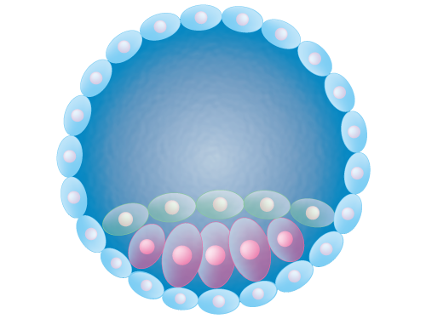

X

1. Which germinal stage of human embryogenesis does the diagram above represent?
2. Implantation
3. Fertilisation
4. Cleavage
5. **Blastulation**
6. During this stage, which structure releases hormones that maintain the endometrium ready for implantation?
7. Placenta
8. **Corpus luteum**
9. Ovary
10. Zygote
11. Which type of stem cells are those identified by the letter X?
12. Totipotent
13. **Pluripotent**
14. Multipotent
15. Adult Stem Cells
16. At which stage of meiosis does genetic recombination, or crossing over, occur at?
    1. **Prophase I**
    2. Prophase II
    3. Metaphase I
    4. Metaphase II
17. Duchenne muscular dystrophy often results in the loss of muscle mass and functional capacity. Areas of the affected muscle fibres are replaced with fat deposits and can result in the muscle appearing larger.

When viewing a sample of an affected muscle under a microscope, the sample would show

* 1. increased numbers of skeletal muscle fibres.
  2. hypertrophy; enlarged diameters of muscle fibres.
  3. multiple peripheral cells undertaking mitosis.
  4. **increased amount of connective tissue and muscle cells of different sizes.**

**Use the pedigree chart below to answer Question 29.**

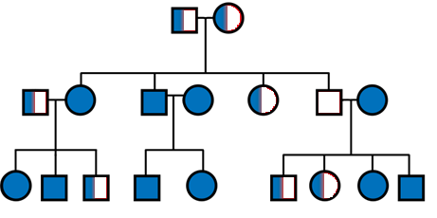

1. The type of inheritance displayed in the pedigree chart is best described as
   1. autosomal dominant.
   2. **autosomal recessive.**
   3. co-dominant.
   4. sex-linked.
2. A bacterial culture contains methyl-labelled thymine (T^). The culture is then transferred to a solution containing unlabelled thymine, and after one round of replication the DNA is analysed. Which of the following could be representative of the analysed DNA?
   1. T^T A A C G

A A T^ T G C

* 1. **T^T^A A C G**

**A A T T G C**

* 1. T T A A C G

A A T T G C

* 1. T^T^A A C G

A A T^ T^ G C

**Section Two: Short answer 50% (103 Marks)**

This section has **eight (8)** questions. Answer **all** questions. Write your answers in the spaces provided.

Spare pages are included at the end of this booklet. They can be used for planning your responses and/or as additional space if required to continue an answer.

* + Planning: If you use the spare pages for planning, indicate this clearly at the top of the page.
  + Continuing an answer: If you need to use the space to continue an answer, indicate in the original answer space where the answer is continued, i.e. give the page number. Fill in the number of the question(s) that you are continuing to answer at the top of the page.

Suggested working time: 90 minutes.

**Question 31 (15 marks)**

Huntington’s disease (HD) is an inherited neurodegenerative disorder due to a defective gene located on chromosome 4. Parents-to-be with a history of HD in their families often visit a genetic counsellor to discuss the possibilities and implications of the disease.

1. It is found that a husband is heterozygous for HD whilst the wife is homozygous recessive.

In the space below, predict the possible genotypes and phenotypes of their future children.

|  |  |  |  |
| --- | --- | --- | --- |
|  | | **Mother** | |
| **h** | **h** |
| **Father** | **H** | **Hh** | **Hh** |
| **h** | **hh** | **hh** |

(5 marks)

|  |  |
| --- | --- |
| **Punnett Square:**  **Father’s genes: Hh (heterozygous)**  **Mother’s gene: hh (homozygous)** | **2** |
| **Key: H – Huntington’s gene h – Normal gene** | **1** |
| **Phenotype: 50% Huntington’s and 50% Normal** | **1** |
| **Genotype: 50% Heterozygous, 50% homozygous normal/recessive** | **1** |

1. Construct a pedigree diagram the genetic counsellor may have drawn to explain the couple’s chances of inheritance.

(7 marks)

Your pedigree should include:

* two generations of the family
* the wife’s sister and brother whom are all unaffected
* the husband’s older brother who died from HD symptoms
* the prediction of two future children, one of each gender

|  |  |
| --- | --- |
| **Use of a key** | **1** |
| **Couple and their siblings in generation 1** | **1** |
| **Children in generation 2** | **1** |
| **Husband’s brother with HD** | **1** |
| **Wife and siblings not affected** | **1** |
| **Possible offspring (one male, one female)** | **1** |
| **50% offspring with HD** | **1** |

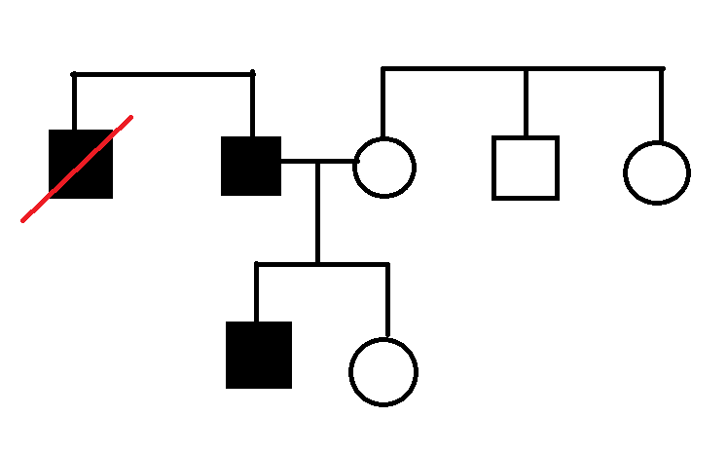

**Note: Either child may be represented as having HD**

1. Describe a suitable prenatal genetic test that could be used to determine if an unborn child has HD, and state one risk associated with the test.

(3 marks)

**Any ONE of the following:**

|  |  |
| --- | --- |
| **Description** | **Marks** |
| Chorionic Villus Sampling | 1 |
| Obtain foetal cells from chorion membrane for analysis | 1 |
| Risk of miscarriage | 1 |

|  |  |
| --- | --- |
| **Description** | **Marks** |
| Amniocentesis | 1 |
| Obtain sample of amniotic fluid cells for analysis | 1 |
| Risk of infection / miscarriage / damage to the foetus | 1 |

|  |  |
| --- | --- |
| **Description** | **Marks** |
| Foetal Blood Sampling | 1 |
| Obtain blood samples from the placenta | 1 |
| Risk of infection / bleeding from sample site / leaking of amniotic fluid / miscarriage / change in foetus heart rate | 1 |

**Question 32 (8 marks)**

A study that began in 2008 aimed to test the safety and effectiveness of a contraception injection on sperm count in 320 healthy men. Conducted at health centres around the world, the men were required to be between 18 – 45 years old and in a monogamous relationship of at least 1 year with a female partner. Each participant underwent testing to ensure they had a normal sperm count of at least 15 million/mL prior to commencement. The contraception shot was given intramuscularly every 8 weeks and consisted of 1200 milligrams of synthetic forms of hormones.

1. Identify the following variables:
2. Independent variable (1 mark)

**Contraception Shot / Injection / Hormones**

1. Dependent variable (1 mark)

**Sperm Count (million/mL) *note: units must be included**

Variables that may affect the outcome of an investigation must be kept constant to ensure a fair test.

1. State two variables that were controlled in the study.

(2 marks)

**Any two of the following:**

* **Age of men (18-45)**
* **Healthy men**
* **Monogamous relationship of 1 year**
* **Female partner**
* **Normal Sperm Count (15million/mL) prior**
* **Injection had same concentration of hormones**
* **Injection was given every 8 weeks**
* **Injection was given intramuscularly**

1. Describe one change that would improve the validity of the data collected in the study.

(2 marks)

**A control group receiving a placebo injection (1) to show that the contraception alone affects the sperm count (1).**

Human Research Ethics Committees play a central role in the ethical oversight of human based research.

1. Describe one principle that this study would have needed to satisfy in order to be ethically sound.

(2 marks)

**Any of the following principles with suitable description:**

* **Voluntary participation (1) subjects should not be pressured into taking the research (1)**
* **Informed consent (1) Participants informed about the objectives, procedures, risks, benefits etc. (1)**
* **Risk of harm (1) Possibility of harm should be minimised, risk-benefit relationship assessed / Appropriate care if adverse reactions occur (1)**
* **Confidentiality / Anonymity (1) Identities of participants are not to be released without consent / Appropriate procedures need to be in place to secure data (1)**

**Question 33 (12 marks)**

The data below shows the percentage of blood that flows to specific organs at rest and during exercise.

|  |  |  |
| --- | --- | --- |
|  | **Blood Flow (%)** | |
| **Organ** | **Exercise** | **Rest** |
| Skeletal Muscle | 70 | 15 |
| Skin | 15 | 5 |
| Stomach | 2 | 25 |

1. Plot the data comparing the two sets of data for the body organs listed in the table above.

(5 marks)

**One mark for the following:**

**Appropriate title stating independent and dependent variables**

**Correctly labelled X and Y axes including organ names**

**Uses correct type of graph**

**Plots data correctly**

**Use of key**

1. Explain how the structure of arteries allow for these alterations in blood flow.

(3 marks)

|  |  |
| --- | --- |
| **Description** | **Marks** |
| Arteries contain smooth muscle | 1 |
| Contract/Vasoconstriction to decrease diameter of vessel | 1 |
| Relaxation/Vasodilation to increase diameter of vessel | 1 |

The increase in blood flow to skeletal muscles during exercise is related to the production of energy. Aerobic exercises are those at a moderate intensity that increase the heart rate and deliver more blood to the muscles, whereas anaerobic exercises are defined as those that prevent you breathing normally.

1. Describe **two** cellular disadvantages and **one** cellularadvantage of anaerobic exercise.

(4 marks)

|  |  |
| --- | --- |
| **Disadvantages** | **Advantages** |
| Production of lactic acid that accumulates  **OR**  Only a small amount of ATP/energy is produced | ATP is regenerated quickly due to less chemical reactions taking place.  **OR**  With oxygen present lactic acid can be converted back to glucose |

**Question 34 (12 marks)**

1. State the three germ layers formed in the embryo after implantation and for each germ layer, identifyone structure in the adult body that develops from it.

(6 marks)

|  |  |
| --- | --- |
| **Germ Layer** | **Structure that forms from it** |
| **Ectoderm** | **hair / nails / skin / nervous system** |
| **Mesoderm** | **heart / blood vessels / skeletal system / muscles** |
| **Endoderm** | **digestive system / liver / pancreas / etc.** |

1. Placental abruption is a condition where the placenta begins to come away from the wall of the womb. Describe one effect this may have on the growing foetus.

(2 marks)

**1 mark for a function of the placenta and 1 mark for the effect of this**

**Functions (One of the following):**

* **Hormones are no longer produced**
* **Nitrogenous waste not removed by mother’s kidneys**
* **Oxygen not supplied**
* **Carbon dioxide not removed**
* **Glucose, amino acids, fatty acids, vitamins and minerals transported**

**Effect (one of the following):**

* **Still birth**
* **Premature birth**
* **Impact on growth of foetus**

1. Patent foramen ovale (PFO) is the name given to the incomplete closure of the hole between the two atria in the heart of newborns. Discuss the importance of the foramen ovale in foetuses and the possible implications of PFO.

(4 marks)

**Two marks for describing importance in foetuses:**

**Foramen ovale allows the blood to bypass the lungs (1)**

**As the lungs are not inflated / not functioning / receives oxygen from the mother (1)**

**Two marks for any two of the possible implications:**

**Shortness of breath / heart palpitations / fatigue / swelling in legs or feet / heart murmurs / bluish skin of baby**

**Question 35 (18 marks)**

The diagram below represents the urinary system of the human body.

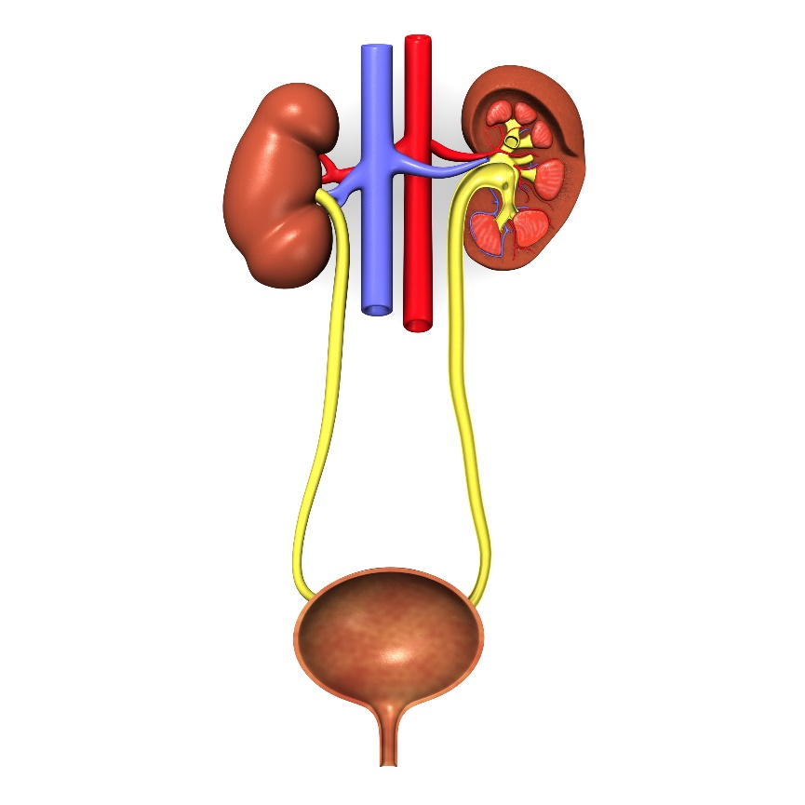

Z

Y

1. Identify the following labelled structures stating a function for each.

(4 marks)

Y **Ureter Carries urine from the kidney to the bladder**

Z **Bladder Collects / Stores urine from the kidney**

1. Describe the processes that occur during excretion in the kidneys.

(6 marks)

**Filtration**

**Fluid is forced out of the blood into the glomerular / Bowmans capsule**

**Reabsorption**

**Substances taken back into the blood vessels from the nephron**

**Secretion**

**Substances moves into the nephron/tubules from the blood/capillaries**

1. Explain how the structure of the nephron relates to its function to excrete wastes.

(4 marks)

**Must relate structure to function. Answers may include any two of the following:**

* **Glomerulus is a network which increases surface area to increase filtration**
* **Glomerular capsule surrounds the glomerulus to collect the fluid filtered out of the blood capillaries**
* **Arteriole leading out of the glomerulus has a smaller diameter than the arteriole leading in to increase pressure/filtration**
* **The tubule has two sets of convolutions and a long loop so that each tubule has a large surface area for reabsorption and secretion**
* **Each kidney has over a million nephrons so the total surface area available for reabsorption and secretion is large**
* **Cells in the PCT have cilia / large numbers of mitochondria to increase reabsorption / increase active reabsorption**

1. Describe the formation of urea in the body and state an organ besides the kidneys that excretes this metabolic waste.

(4 marks)

**Three marks from the following for formation of urea:**

* **Deamination**
* **Amine group / NH2 converted to ammonia**
* **that is further converted to urea**
* **energy / ATP is required**

**One mark from the following for excretory organ:**

* **Skin / sweat gland**

**Question 36 (14 marks)**

When cells begin to grow and divide at a faster rate than those around them they produce masses known as tumours. If cancerous, these tumours can be treated by radiation therapy that causes double stranded breaks in nucleic acids during the M phase of the cell cycle.

1. Explain how radiation therapy causes cancerous cells to die if the cells attempt to divide.

(3 marks)

**DNA replication cannot occur (1)**

**due to missing / loss of chromosomal material / nucleotides (1)**

**cell undergoes apoptosis as the DNA is damaged / DNA loses integrity (1)**

The diagram below shows the structure of a tRNA molecule.

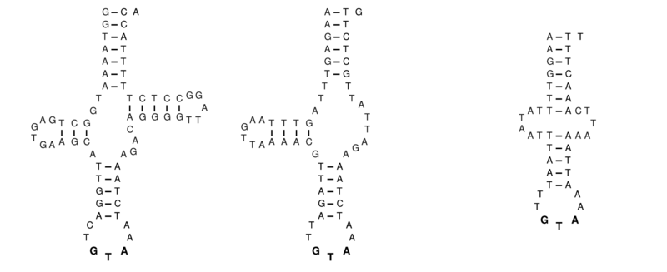

1. Explain the structure of the tRNA molecule that gives it this specific shape.

(3 marks)

**Bases bonded/paired by Hydrogen bonds**

**Complementary base pairing / AU and GC**

**Loops / clover leaf shape have no bonds / not complementary**

1. Outline the process that would result in the production of a protein from a strand of mRNA.

(5 marks)

**Any five of the following:**

* **Ribosome binds to mRNA**
* **Ribosome reads three bases at a time / codon**
* **tRNA brings the corresponding amino acid to the ribosome**
* **matches due to complementary anti-codon**
* **peptide bond binds amino acids together**
* **polypeptide/protein forms**
* **stop codon is reached**
* **protein is released from ribosome**

1. Identify a specialised cell that produces proteins for transport outside the cell.

(1 marks)

**Answers may include:**

**Langerhans cells of the pancreas / saliva-producing cells / gastric cells / parietal cells / lactiferous cells etc.**

1. State one cell organelle that would be found in abundance in the cell identified in part (d) above, and give a reason why.

(2 marks)

**1 mark for structure/organelle and 1 mark for reasoning:**

* **Golgi body – modify and package proteins**
* **Endoplasmic reticulum – folding and transport of proteins**
* **Mitochondria - produce ATP for transport**

**Question 37 (12 marks)**

The digestive systems assists in supplying the cells of the body with the essential nutrients required for metabolism.

1. Name one enzyme that breaks down proteins in the body and state the site of its production.

(2 marks)

**One mark for enzyme and 1 mark for site of production from the following:**

* **Pepsin - Gastric glands / stomach lining**
* **Trypsin - Pancreas**
* **Peptidase – Small intestine**

The diagram below shows an enzyme produced by the normal gene and one by a mutated gene.



Functional Enzyme Mutated Enzyme

1. Explain why the mutated form of the enzyme could not catalyse a chemical reaction.

(3 marks)

**Changes the shape of the active site of the enzyme (1)**

**The enzyme can no longer bind to its substrates as the active site is no longer complementary to the substrate.**

**If the enzyme cannot bind to its substrate, then it cannot serve its function anymore.**

1. Describe the difference between mechanical and chemical digestion.

(2 marks)

**Mechanical digestion involves physically breaking the food into smaller pieces (1)**

**Chemical digestion involves breaking down the food into simpler nutrients / smaller molecules using enzymes (1)**

Irritable bowel syndrome (IBS) is a common problem associated with the digestive system and includes symptoms of diarrhoea and constipation.

1. By referring to the process of peristalsis, explain how diarrhoea occurs.

(5 marks)

**Increased / accelerated bowel movements / peristalsis where**

**Muscle contracts behind food**

**Muscle relaxes in front**

**Occurs in waves**

**Results in soft watery stool**

**Question 38 (12 marks)**

The skeletal system of the human body is shown in the diagram below.

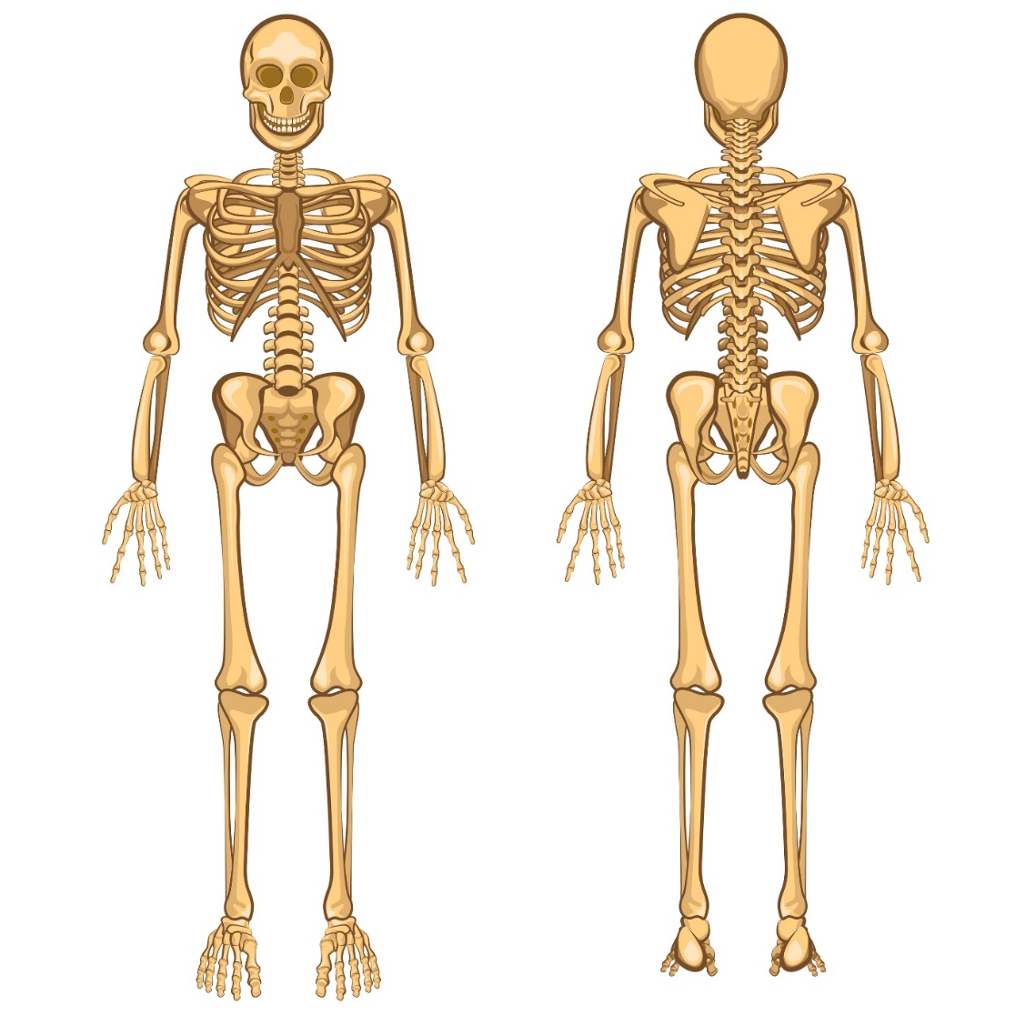

A

D

B

C

1. Identify the letter/s that make up part of the axial skeleton.

(1 mark)

**A and C**

1. The femur is an example of a long bone. Draw a cross section diagram through a long bone and identify the compact bone, spongy bone and epiphysis.

(3 marks)

**Appropriately drawn cross section identifying spongy bone (1), epiphysis (1) and compact bone (1)**

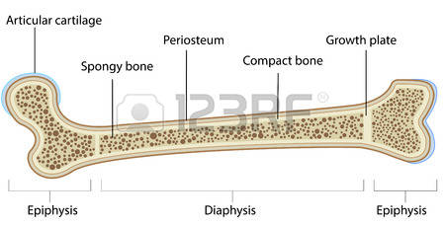

1. Outline how two named features of the hip joint help prevent injury and allow for stability when moving.

(4 marks)

**1 mark for feature and 1 mark for how they prevent injury and allow stability:**

**Any two of the following:**

* **Shape of the articular surface/bones which allow them to fit together without rubbing/touching**
* **Ligaments attaching bone to bone which restrict movement**
* **Joint capsule / fibrous capsule is lined with synovial membrane / encloses / supports joints**
* **Meniscus fibrocartilage improves the fit between adjacent bones**

A 60-year old patient is exhibiting signs of hip pain, decreased range of motion, and a popping feeling when walking.

1. State the degenerative disease most likely attributed to this patient.

(1 mark)

**Osteoarthritis**

1. Suggest a management plan the doctor may assign to help assist the patient.

(3 marks)

**Three of the following:**

* **Weight loss / control**
* **Exercise**
* **Paracetamol/non-steroidal anti-inflammatory drugs**
* **Physiotherapy**
* **Injections of glucosamine/corticosteroids**

**Section Three: Extended answer 20% (40 Marks)**

This section contains **three (3)** questions. You must answer **two (2)** questions. Make sure you clearly indicate which question you are answering and write your answers in the space provided.

Spare pages are included at the end of this booklet. They can be used for planning your responses and/or as additional space if required to continue an answer.

* + Planning: If you use the spare pages for planning, indicate this clearly at the top of the page.
  + Continuing an answer: If you need to use more space to continue an answer, indicate in the original answer space where the answer is continued, i.e. give the page number. Write the number of the question(s) that you are continuing to answer at the top of the additional space page.

Responses could include clearly labelled diagrams with explanatory notes; lists of points with linking sentences; clearly labelled tables and graphs; and annotated flow diagrams with introductory notes.

Suggested working time: 50 minutes.

**Question 39 (20 marks)**

During the 1944-45 winter of World War II (Dutch Hunger Winger), many pregnant mothers were forced into severe malnourishment. The babies born during this time were smaller than average. As a result, the following two generations of children were also underweight.

1. Describe **two** epigenetic mechanisms that may explain why subsequent offspring from the Dutch Hunger Winter inherited lower birthweights. In your answer, refer to what epigenetics is and a possible reason that may have caused the changes.

(10 marks)

**Must include:**

* **Epigenetics is the altering of a gene without changing the gene structure (1)**
* **Due to starvation / lack of nutrients during pregnancy (1)**

**Any eight of the following:**

* **Alter the structure of chromatin (1)**
* **Acetylation (1)**
  + **Addition of acetyl group to a histone (1)**
  + **Enhances gene expression (1)**
* **Methylation (1)**
  + **Addition of methyl group to DNA molecule (1)**
  + **Occurs at CpG site / cytosine is adjacent to guanine (1)**
  + **Inhibits gene expression (1)**
* **Interferes with protein production / transcription and translation (1)**

The subjects of the study were required to have samples of their DNA taken for profiling by scientists.

1. State the name and outline the process used to create DNA fingerprints.

(6 marks)

|  |  |
| --- | --- |
| **Description** | **Marks** |
| (Gel) Electrophoresis | 1 |
| DNA cut by restriction enzymes  Sections of DNA / DNA pieces placed at one end of gel bed  Electric current is passed through the gel / voltage applied  Negatively charged DNA moves towards positive electrode / terminal  DNA moves through the gel at different speeds / smaller moves faster than larger  Bands form representing different size fragments of DNA | 1-5 |

1. Discuss ethical implications that should be considered when using genetic profiling.

(4 marks)

**Any four of the following or other suitable answers:**

* **Who the genome/profile belongs to / Ownership of the genome/profile**
* **Privacy/confidentiality of the subject**
* **Potential for discrimination**
* **Inappropriate applications of genetic testing**
* **Misuse of genome/profiles such as DNA data banks**

**Question 40 (20 marks)**

Jill is a 46-year-old woman who recently began attending ‘boxercise’ classes at her local gym. At the end of each session, she finds herself fatigued, and breathing more quickly than normal.

1. Explain the theory behind the physiology of muscle fibre contractions that allow Jill to move during her ‘boxercise’ session.

(7 marks)

**Any seven of:**

* **Energy from ATP is required**
* **Actin are thin filaments**
* **Myosin are thick filaments**
* **Actin slides over myosin**
* **Z lines become closer together / shorten**
* **Sarcomere shortens**
* **Filaments do not change length**
* **Cross bridge forms**
* **I band shortens**

1. Outline the mechanics of breathing.

(10 marks)

|  |  |
| --- | --- |
| **Description** | **Marks** |
| Inspiration / Inhalation | **1** |
| Diaphragm contracts / flattens  Intercostal muscles contract  Ribs pulled upwards and out  Lung volume increases  Lung pressure decreases so air moves in | **1 – 4** |
| Exhalation / Expiration | **1** |
| Diaphragm relaxes / domes  Intercostal muscles relax  Ribs move downwards and in  Lung volume decreases  Lung pressure increases so air moves out | **1 – 4** |

1. Describe the process by which oxygen molecules are transported across the cell membrane.

(3 marks)

**Diffusion (1)**

**Occurs directly across the plasma membrane / no carrier or channel proteins (1) From area of high concentration to low concentration (1).**

**Question 41 (20 marks)**

There is an increasing occurrence of infertility in Australia, with one in six couples experiencing fertility problems. One cause of infertility is the decreased production of sperm and/or egg cells.

1. Outline the sequence of DNA replication.

(5 marks)

* **Any 5 of the following:**
* **Enzyme/Helicase breaks the weak hydrogen bonds between DNA strands/base pairs**
* **Separates the DNA chains/strands**
* **The separate DNA chains/strands now can serve as templates**
* **A primer (short RNA sequence) attaches to the DNA where replication will begin.**
* **DNA Polymerase moves to the RNA primer and attaches free floating nucleotides to the unpaired DNA strands**
* **DNA is replicated in a 5’ to 3’ direction.**
* **Leading strand, continuous replication**
* **Lagging strand, Okazaki fragments**
* **DNA ligase attaches sections of DNA to complete the new strands.**

1. Compare and contrast the processes of gametogenesis in males and females.

(10 marks)

|  |  |  |
| --- | --- | --- |
| **2** | **Spermatogenesis** | **Oogenesis** |
| **Similarities**  **One mark per pair**  **1-3** | **Both start with germ cells / germinal epithelium (gonad)** | |
| **Both start with mitosis to produce multiple cells** | |
| **Both involve cell growth before mitosis** | |
| **Both involve meiosis/reduction division/ create haploid cells** | |
| **Differences**  **One mark per pair**  **1-5** | **Occurs in testes** | **Occurs in ovaries** |
| **Millions/large numbers produced daily** | **One/few produced per month** |
| **Released during ejaculation** | **Released during ovulation** |
| **Begins at puberty** | **Begins before birth** |
| **Continues throughout life** | **Stops at menopause** |
| **Four sperm per meiosis** | **1 egg per meiosis** |
| **Polar bodies not produced / equal division** | **Polar bodies produced / unequal division** |
| **Cytoplasm is reduced in sperm** | **Cytoplasm is enhanced in egg** |
| **Sperm are motile** | **Eggs are not motile** |

A variety of assisted reproductive technologies have helped in overcoming some infertility problems.

1. Describe how in-vitro fertilisation (IVF) differs from natural fertilisation and discuss the risks involved in IVF.

(5 marks)

|  |  |
| --- | --- |
| **Description** | **Marks** |
| Fertilisation occurs outside the body of a female rather than inside | 1 |
| After fertilisation dividing cells are transferred to the mother rather than occurring inside the fallopian tube | 1 |
| Multiple births / premature births / low birthweights / miscarriage / complications when retrieving eggs / ectopic pregnancy | 1-3 |

**Acknowledgements**

**Question 15**

AJ.iitm (2012) Ballerina Logo [Artwork] Retrieved April 10, 2017, from <https://commons.wikimedia.org/wiki/File:Ballerina_logo.png?uselang=en-gb#/media/File:Ballerina_logo.png>

**Question 20**

en:User:Wapcaplet (2006) Heart numlabels [Artwork] Retrieved April 10, 2017 from

<https://commons.wikimedia.org/wiki/File:Heart_numlabels.svg?uselang=en-gb>

**Question 24**

Database Center for Life Science (2013) Embryo [Artwork] Retrieved April 10, 2017 from

<https://commons.wikimedia.org/wiki/File:Blastocyst_embryo.png>

**Question 29**

Walker, J (2006) Pedigree Chart [Artwork] Retrieved April 10, 2017 from <https://commons.wikimedia.org/wiki/File:Autosomal_Recessive_Pedigree_Chart.svg?uselang=en-gb>

**Question 34**

3drenderings (n.d.) Urinary System [Artwork] Retrieved 27 March, 2017 from <https://www.dreamstime.com/royalty-free-stock-photos-urinary-system-image10634818#res18124506>

**Question 36**

Knarf (2012) An example of an aberrant tRNATyr [Artwork] Retrieved 24 May, 2017 from

<https://commons.wikimedia.org/wiki/File%3AMt-tRNA(Tyr).png>

**Question 37**

Brancaesova (n.d.) Human Skeleton [Artwork] Retrieved 27 March, 2017 from <https://www.dreamstime.com/royalty-free-stock-images-human-skeleton-vector-illustration-body-anatomy-internal-organ-image34569329#res18124506>